1. In the last lecture, we started the process of creating environment.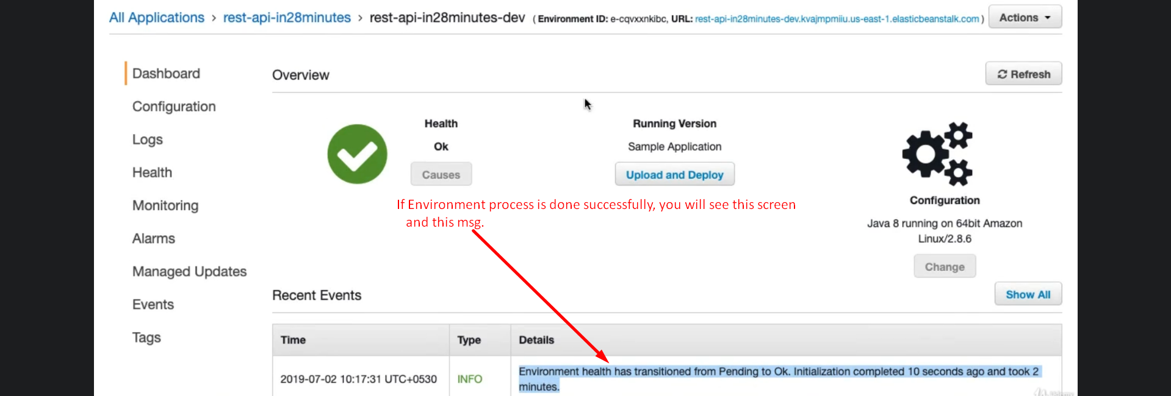
2. 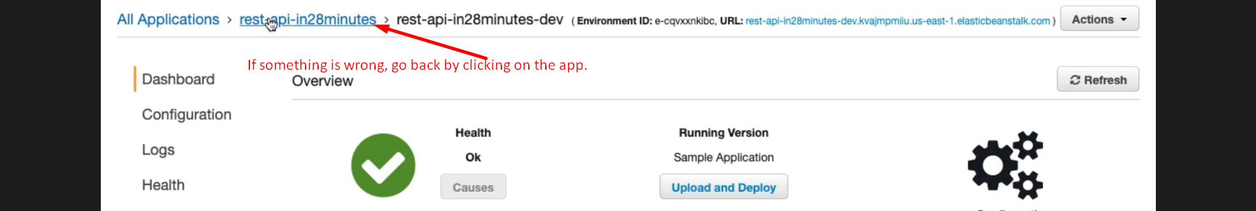  
   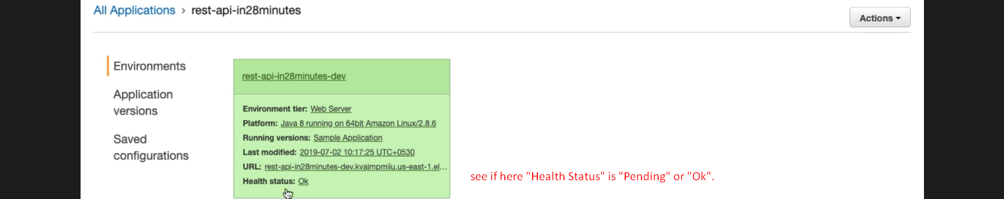
3. 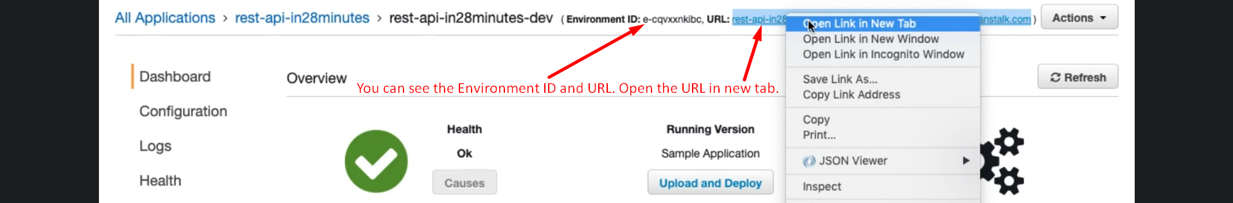
4. 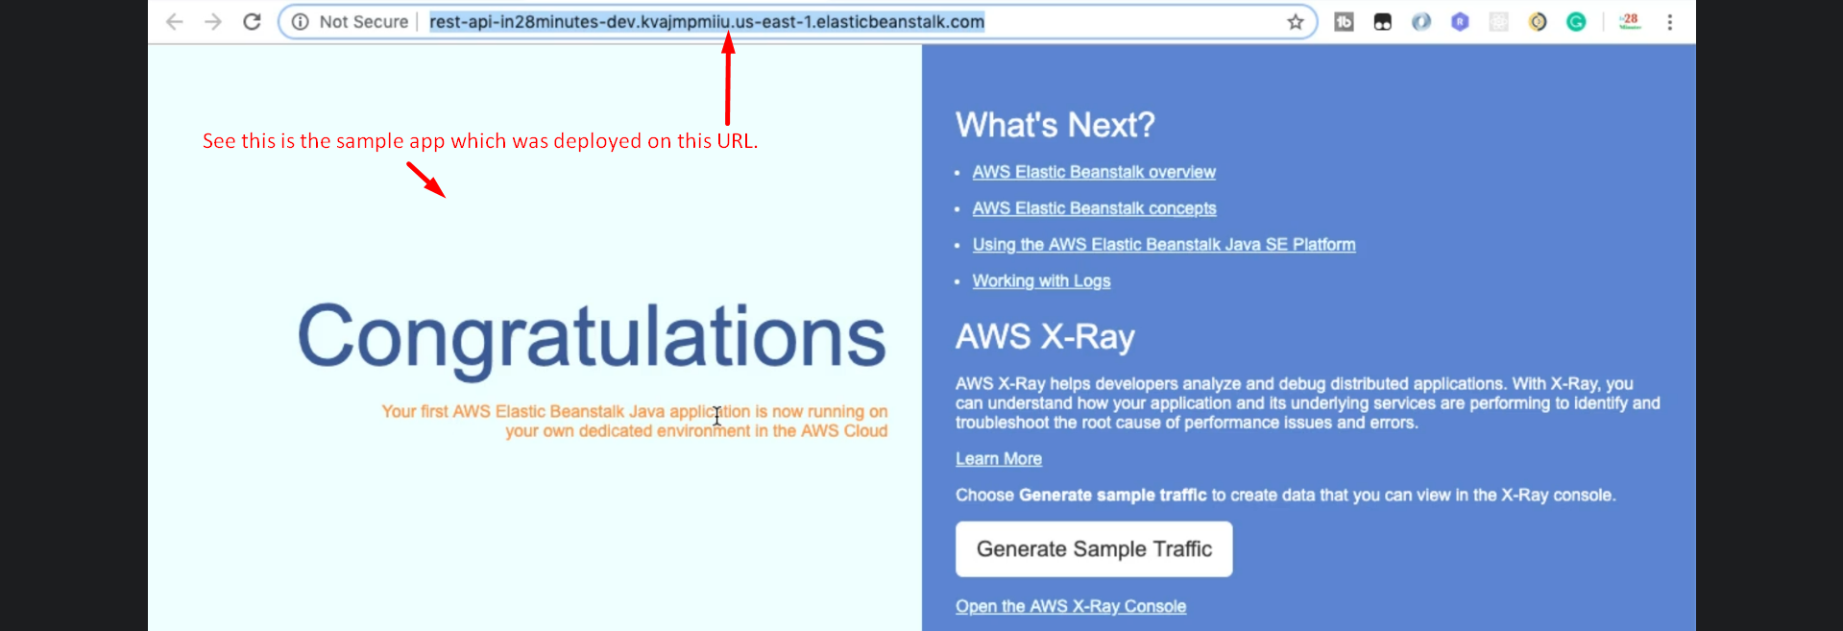
5. 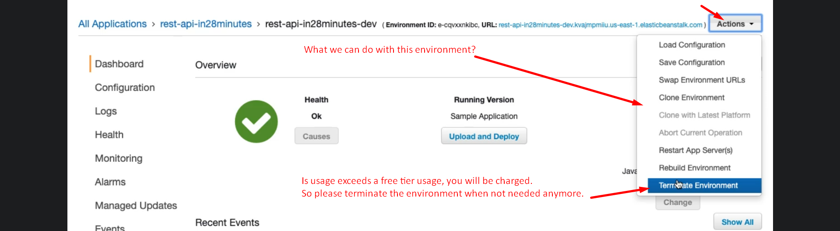
6. 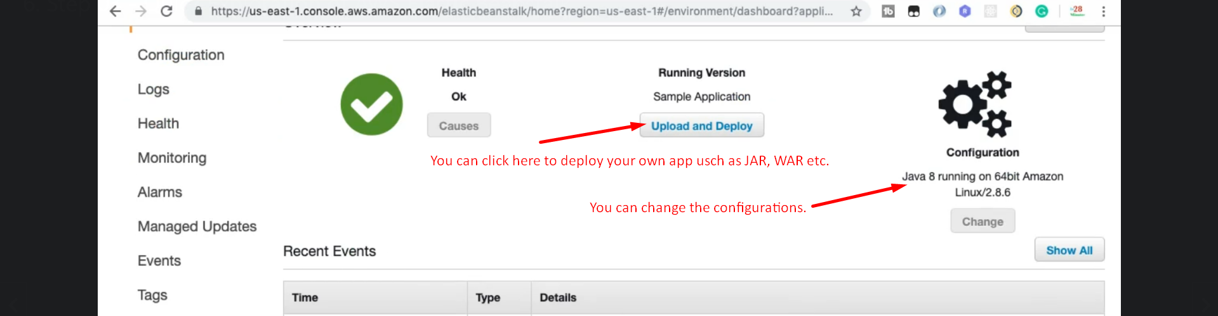
7. 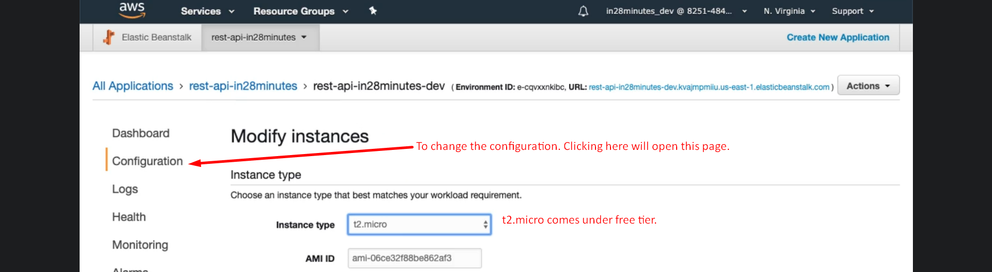
8. 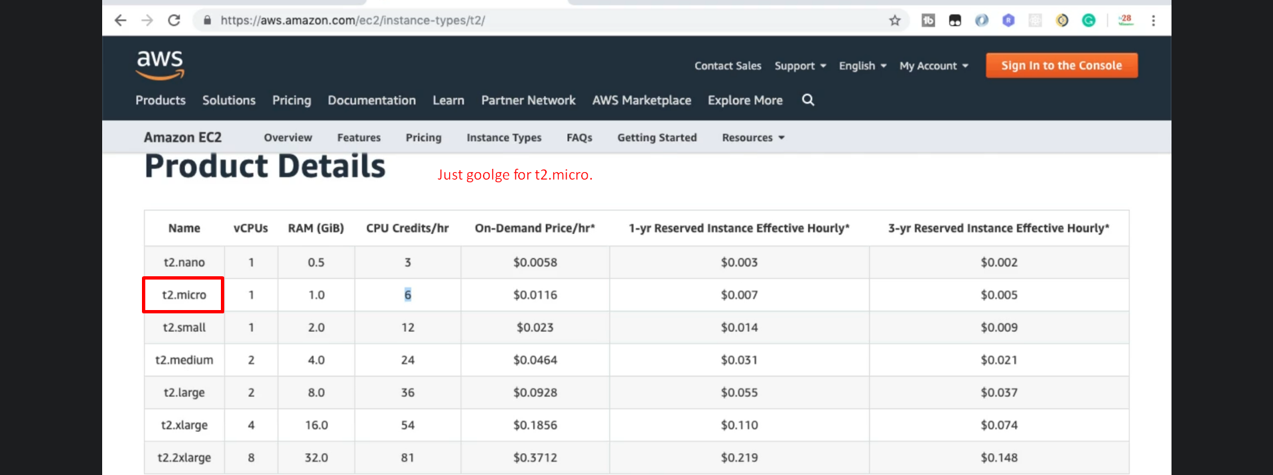
9. 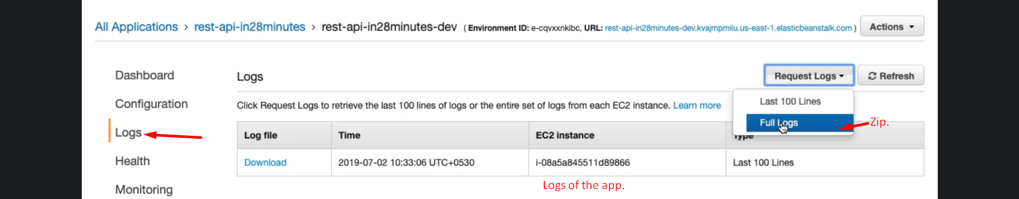
10. 
11. 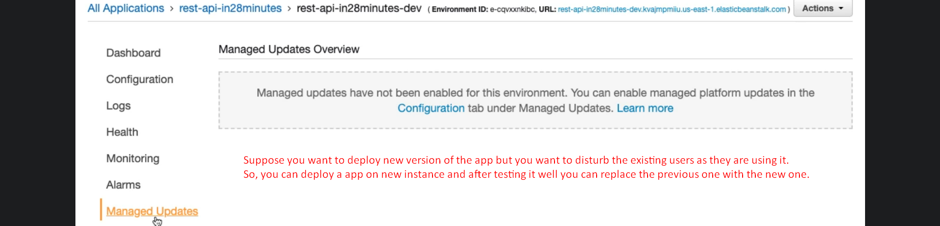
12. 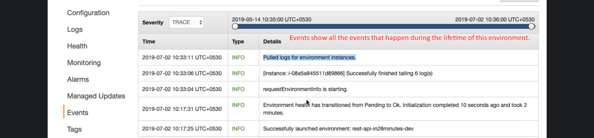
13. 